1. **QUESTION NUMBER :1**

write the query joining tables orders, orderdetails, products, customers, payments and produce the below output

SELECT orders.orderNumber,products.productName,customers.customerName,payments.amount,payments.checkNumber

FROM orders

INNER JOIN orderdetails

ON orders.orderNumber = orderdetails.orderNumber

INNER JOIN products

ON orderdetails.productCode = products.productCode

INNER JOIN customers

ON orders.customerNumber = customers.customerNumber

INNER JOIN payments

ON payments.customerNumber = customers.customerNumber

WHERE orders.orderNumber=10100;

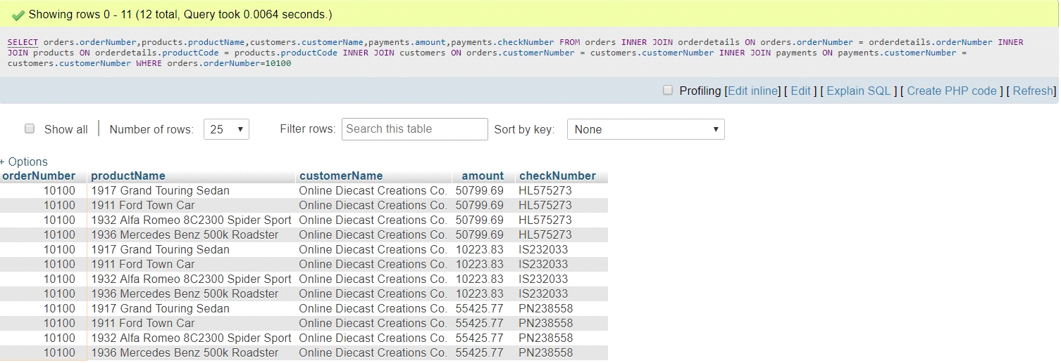

1. **QUESTION NUMBER :2**

write the query to find the total paid amount for the order 10100

SELECT orders.orderNumber,SUM(payments.amount) AS total_paid_amount_for_the_order_10100

FROM orders

INNER JOIN orderdetails

ON orders.orderNumber = orderdetails.orderNumber

INNER JOIN products

ON orderdetails.productCode = products.productCode

INNER JOIN customers

ON orders.customerNumber = customers.customerNumber

INNER JOIN payments

ON payments.customerNumber = customers.customerNumber

WHERE orders.orderNumber=10100;

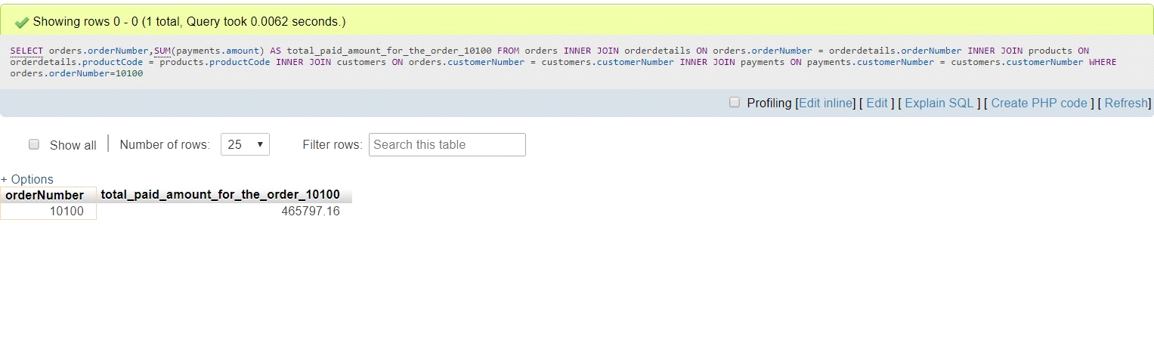

**3) QUESTION NUMBER:3**

write the query to find all the checkNumber using which payment has done for the order 10100

SELECT DISTINCT orders.orderNumber,payments.checkNumber

FROM orders

INNER JOIN orderdetails

ON orders.orderNumber = orderdetails.orderNumber

INNER JOIN products

ON orderdetails.productCode = products.productCode

INNER JOIN customers

ON orders.customerNumber = customers.customerNumber

INNER JOIN payments

ON payments.customerNumber = customers.customerNumber

WHERE orders.orderNumber=10100;

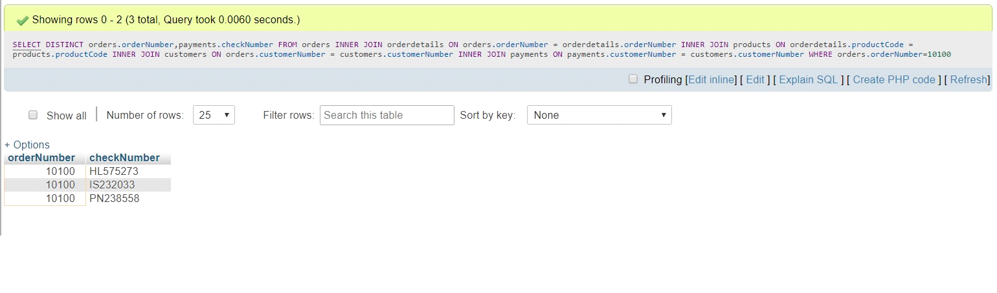

**4) QUESTION NUMBER 4:-**

In the table products write the query to find least value in the column quantityInStock, and also the maximum value in

SELECT MIN(quantityInStock) AS min_value_in_quantityInStock,MAX(quantityInStock) AS max_value_in_quantityInStock FROM products;

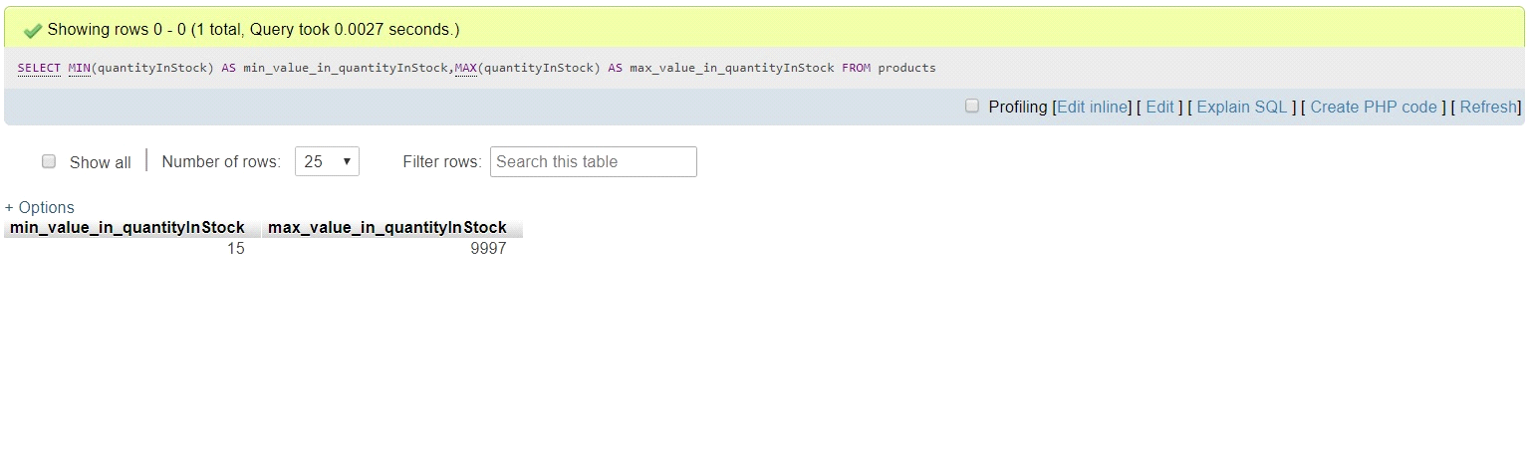

**5) QUESTION NUMBER 5:-**

write the sql to join products , productlines using subquery and reproduce the below output

SELECT products.productCode,products.productLine,productLines.htmlDescription

FROM `products`

INNER JOIN productlines

ON products.productLine=productlines.productLine

WHERE products.productLine=(SELECT productLine FROM productlines WHERE productLine='Classic Cars')

AND (productCode='S12_3380'OR productCode='S12_3891' OR productCode='S12_3990') ;

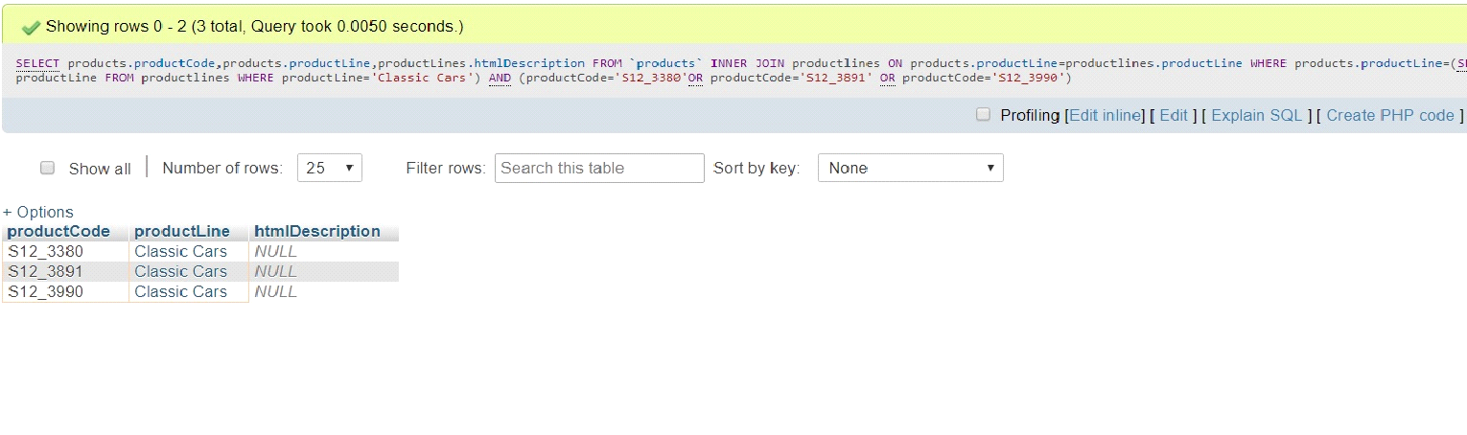

**6) QUESTION NUMBER 6:-**

write the sql to find count of records in productliness where htmlDescription matches NULL;

select count(*) as NULL_COUNT from productlines group by htmlDescription;

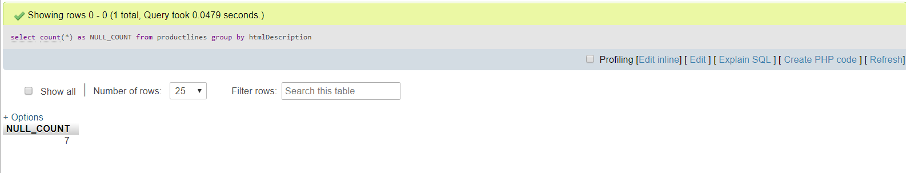

**7) QUESTION NUMBER 7:-**

convert the date '2019-07-18 12:49:24' to the format 18-Jul-Thu

SELECT DATE_FORMAT('2019-07-18 12:49:24' ,'%d %b %a') AS output;

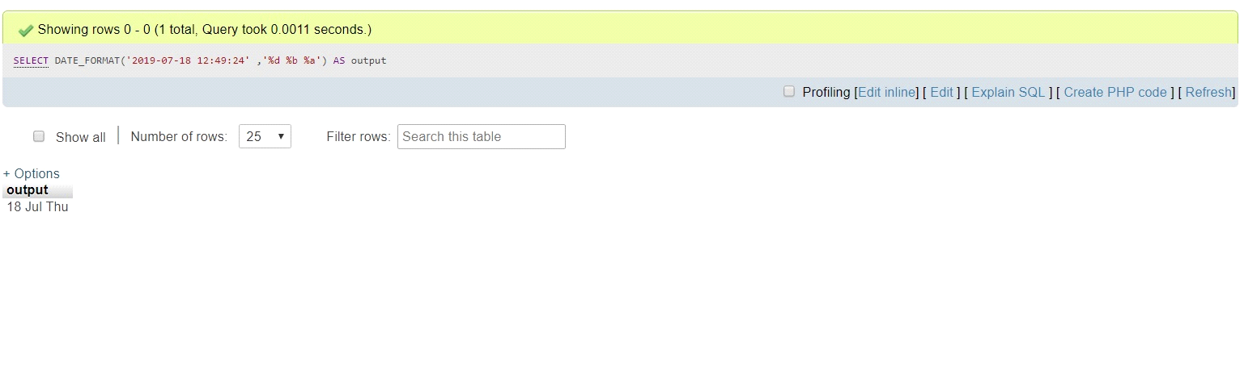

**8) QUESTION NUMBER 8:-**

write a query to find 3rd highest amount in the table payments

SELECT amount

FROM payments e1

WHERE 3-1 = (SELECT COUNT(DISTINCT amount) FROM payments e2

WHERE e2.amount > e1.amount);

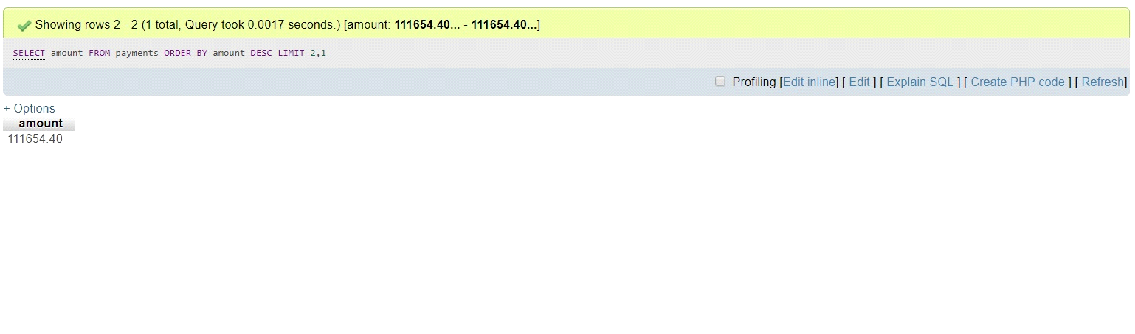

**9) QUESTION NUMBER 9:-**

write a query to find contactFirstName in customers table that starts with 'C' and ends with 'a'

SELECT contactFirstName FROM customers WHERE contactFirstName LIKE 'C%a '

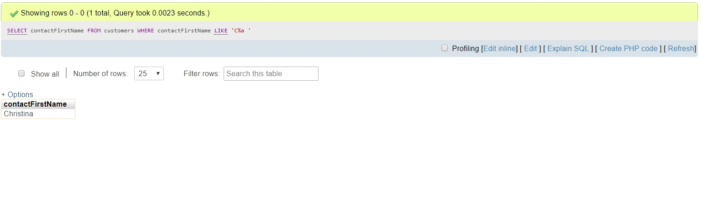

**10) QUESTION NUMBER 10:-**

write a query to find a record in productlines that is not mapped to any record in products

SELECT productLines.productLine,productLines.textDescription,productLines.htmlDescription,productLines.image

FROM `productlines`

INNER JOIN products

ON products.productLine = productlines.productLine

WHERE productLines.productLine <> products.productLine;

